- Unzip jdevstudio10133.zip to <new folder> your local drive local drive.
- Place teisaacs.sqrext.SqrAddin.xxxx.jar in <new folder>\jdev\extensions directory
- Run JDeveloper from <new folder>\jdeveloper.exe

Note: Do not use the New SQR feature – Project and new file wizard not working yet

Syntax Highlighting – Tools > Preferences
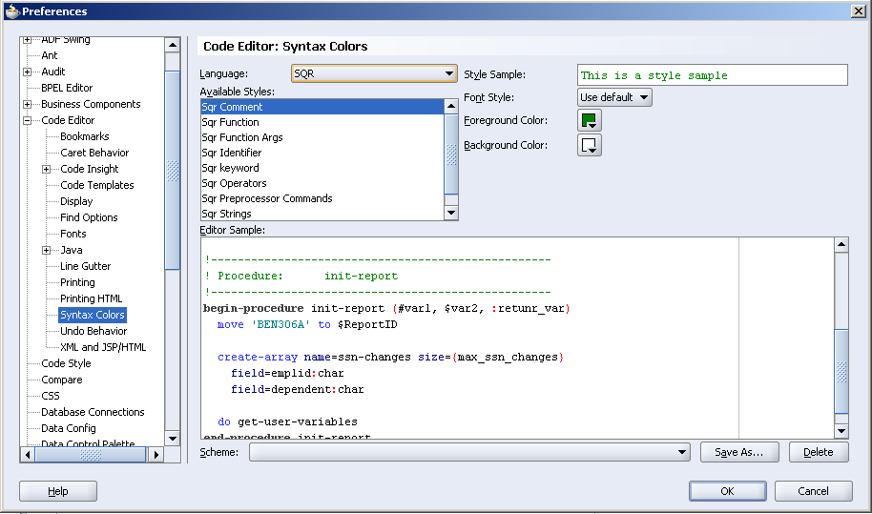

Insight Data
Invoke with CTRL-SPACE key stroke
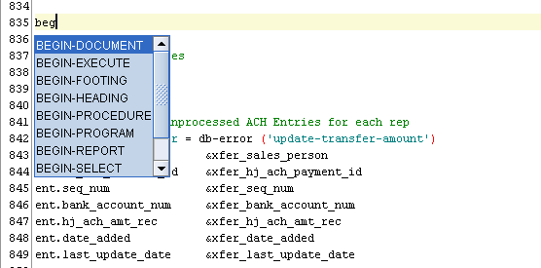
Insight cont. – global variables, Commands and functions
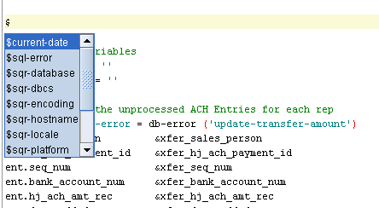

Structure View Window – Double click to go to procedure 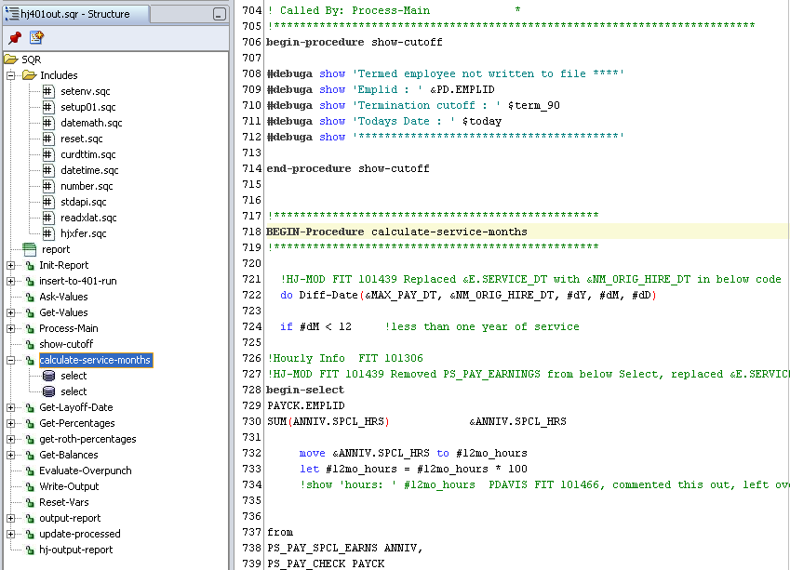

Block Comment and Uncomment

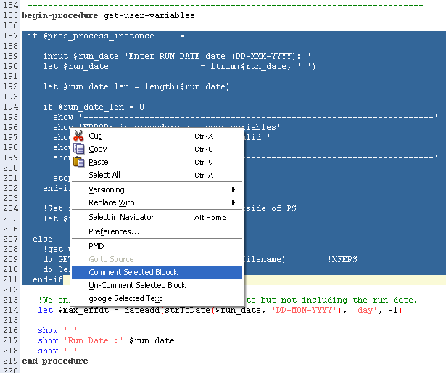

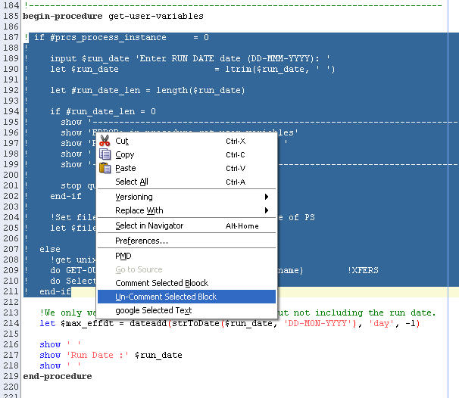

Highlight Search Results

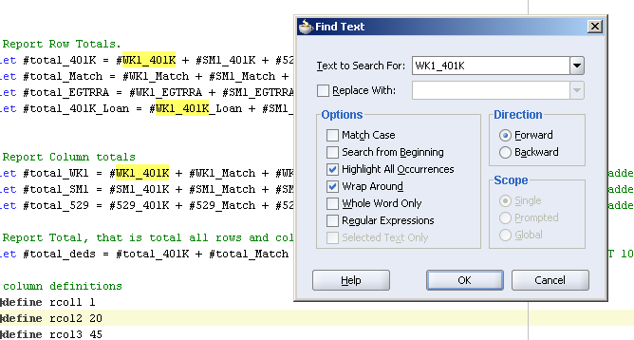

Saved history and history compares (Edit Histories) – Source / History tabs at bottom
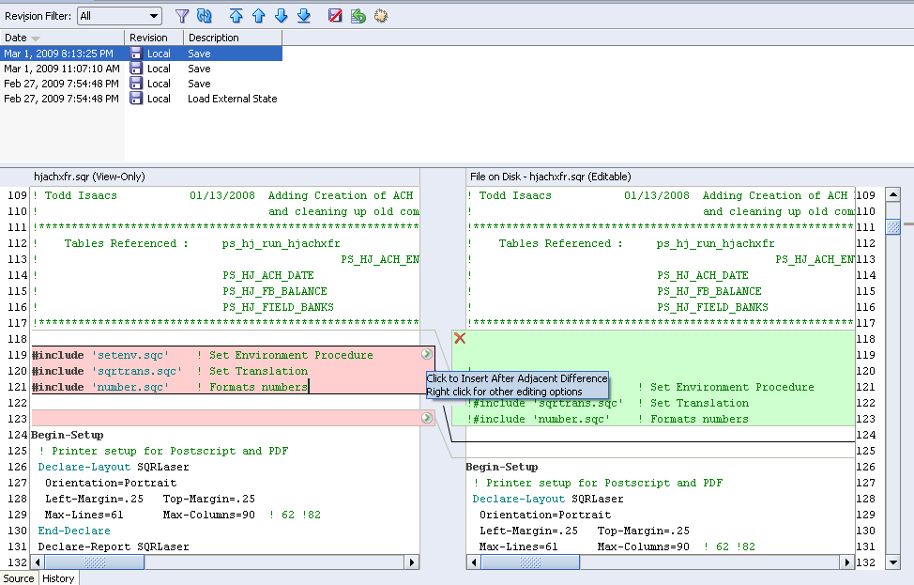

Right Click Compares
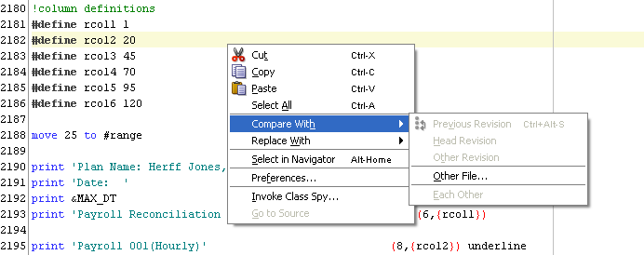

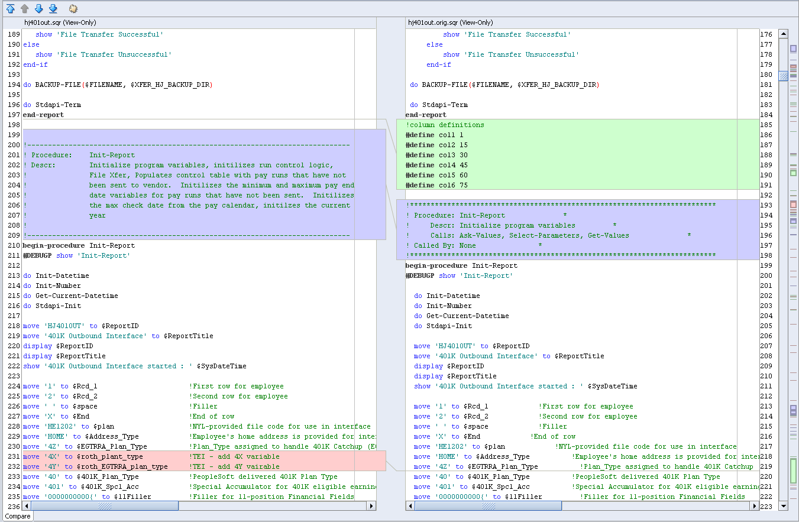

Right Click Go To Procedure (Local only) – jumps to the local function
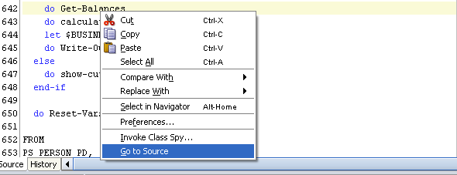

Built-in Database tools
